Aerophone Band
Aerophone is a not-for-profit band for woodwind, brass and percussion players who wish to enrich their playing experience. This is a great opportunity to improve skills, work on more challenging music, and be in a group where everyone is truly committed to making great music! The emphasis for the ensemble will be on developing students’ musical abilities through a diverse selection of literature.

Aerophone Director

Richard Holod has more than 25 years experience teaching junior high and high school. He has been a guest conductor for both All-District and All-County ensembles. Mr. Holod is also very involved in the New York State School Music Association. He has hosted both Solo and Large Ensemble festivals and has chaired ensembles and Area All-State festivals. Mr. Holod teaches at Roy C. Ketcham High School

.
Aerophoneband.com

Richard Holod
Attn. Aerophone
16 Prospect Street
New Paltz, NY 12561

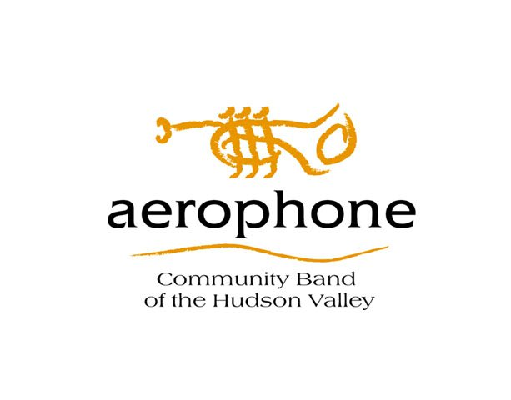

Summer 2014
Program

The summer session is for musicians who have completed grade 7 through adults and will run for six weeks. You may register for any number and combination of weeks.

Musicians must provide their own music stands.
For further information, please call (845) 417-5568, send an e-mail to aerophoneband@gmail.com or visit aerophoneband.com.
Sessions will be held at:
New Hackensack Reformed Church
1580 Route 376
Wappingers Falls, NY 12590
At the intersection of New Hackensack Road and Route 376.

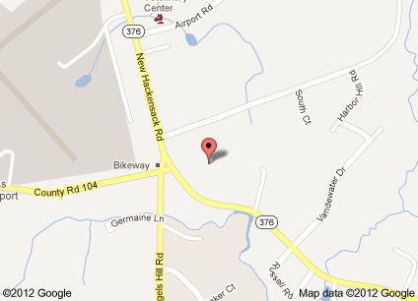

Keep the beat during the dog days of summer! Join the Aerophone Band summer program!

Week 1 W, R 6/25 & 6/26
Week 2 T, W 7/1 & 7/2
Week 3 T, W 7/8 & 7/9
Week 4 W, R 7/16 & 7/17
Week 5 T, W 7/22 & 7/23
Week 6 T, W 7/29 & 7/30
Register for one week or several. Each week is independent of the others.
All sessions are 6:30-8:30pm
$20 per weeklong session.
Register for five weeks and get the sixth FREE!
Tuition is non-refundable
Name:___________________________
Address: ________________________
________________________________
Phone:___________________________
Cell/emergency___________________
E-mail:___________________________
Instrument:_______________________
For Students:
Parent names_____________________
School:___________________________
I will attend:
_______Week 1
_______Week 2
_______Week 3
_______Week 4
_______Week 5
_______Week 6
_____weeks @ $20=_________
If attending 6 weeks, deduct $20
Checks payable to Aerophone
Amount enclosed: ____________
Please enclose this slip with payment and send to:
Richard Holod Attn: Aerophone
16 Prospect Street
New Paltz, NY 12561

